TM2 – SQL Functions
Assignment 1
Question:
Write a query to display the current date. Label the column Date.
Query:
SELECT SYSDATE AS "Date"
FROM DUAL;
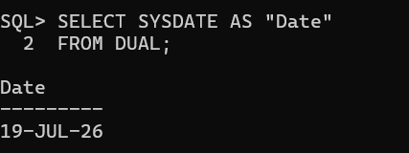
Assignment 2
Question:
The HR department needs a report to display the employee number, last name, salary, and salary increased by 15.5% (expressed as a whole number) for each employee. Label the column New Salary.
Query:
SELECT EMPNO,
ENAME,
SAL,
ROUND(SAL * 1.155) AS "New Salary"
FROM EMP_WIPRO;
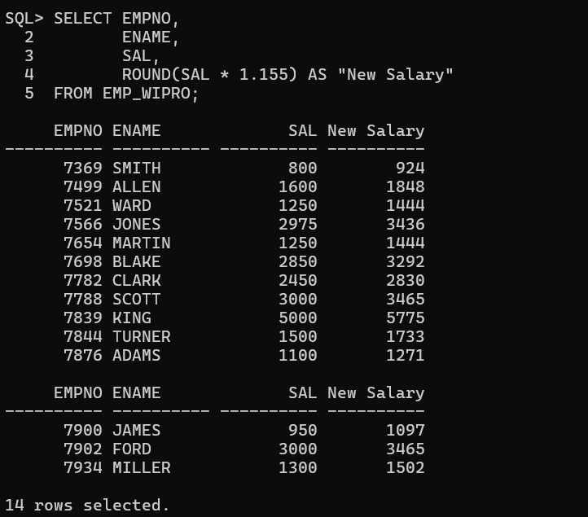

Assignment 3
Question:
Modify the previous query to add a column alias that subtracts the old salary from the new salary. Label the column Increase.
Query:
SELECT EMPNO,
ENAME,
SAL,
ROUND(SAL * 1.155) AS "New Salary",
ROUND(SAL * 1.155) - SAL AS "Increase"
FROM EMP_WIPRO;
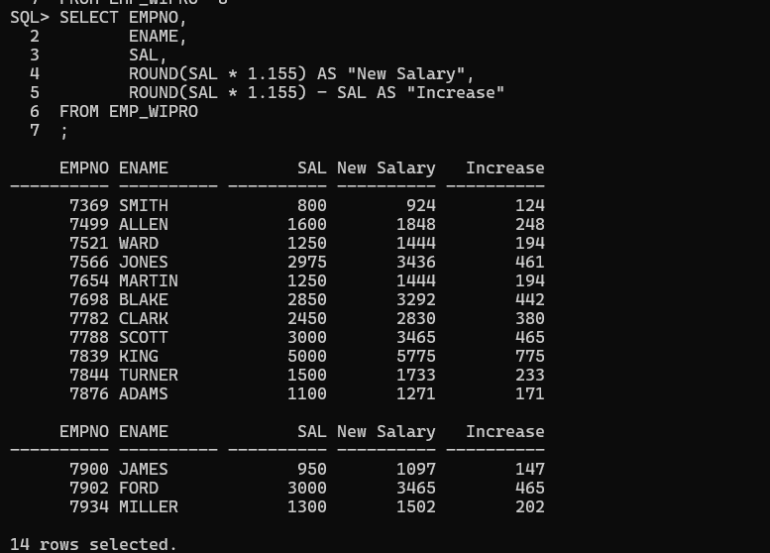
Assignment 4
Question:
Write a query that displays the ENAME (with the first letter uppercase and all other letters lowercase) and the length of the ENAME for all employees whose name starts with the letters J, A, or M. Give each column an appropriate label. Sort the results by the employees' names.
Query:
SELECT INITCAP(LOWER(ENAME)) AS "Employee Name",
LENGTH(ENAME) AS "Name Length"
FROM EMP_WIPRO
WHERE ENAME LIKE 'J%'
OR ENAME LIKE 'A%'
OR ENAME LIKE 'M%'
ORDER BY ENAME;
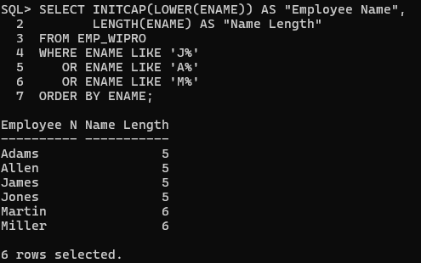
Assignment 5
Question:
Rewrite the query so that the user is prompted to enter a letter that starts the last name. For example, if the user enters H, then the output should show all employees whose last name starts with H.
Query:
ACCEPT CH CHAR PROMPT 'Enter Starting Letter: '

SELECT ENAME
FROM EMP_WIPRO
WHERE ENAME LIKE UPPER('&CH') || '%';
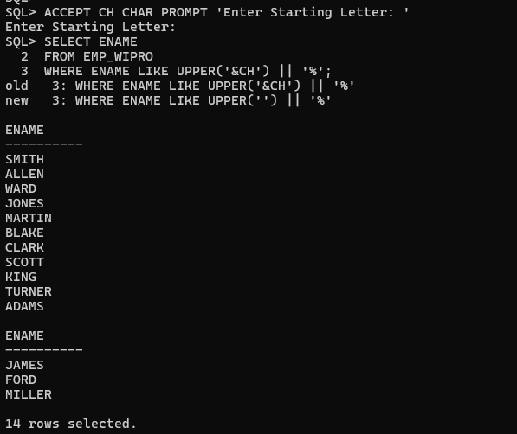
Assignment 6
Question:
The HR department wants to find the length of employment for each employee. For each employee, display the ENAME and calculate the number of months between today and the date on which the employee was hired. Label the column MONTHS_WORKED. Order the results by the number of months employed. Round the number of months up to the closest whole number.
Query:
SELECT ENAME,
ROUND(MONTHS_BETWEEN(SYSDATE, HIREDATE)) AS MONTHS_WORKED
FROM EMP_WIPRO
ORDER BY MONTHS_WORKED;

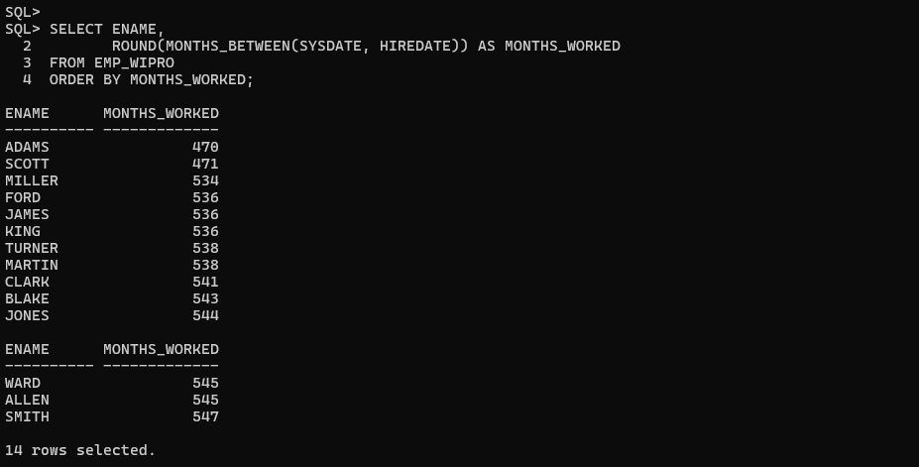 Assignment 7
Question:
Create a report that produces the following for each employee:
<Employee Name> earns <Salary> monthly but wants <3 times Salary>.
Label the column Dream Salaries.
Query:
SELECT ENAME || ' earns ' || SAL ||
' monthly but wants ' || (SAL*3) AS "Dream Salaries"
FROM EMP_WIPRO;
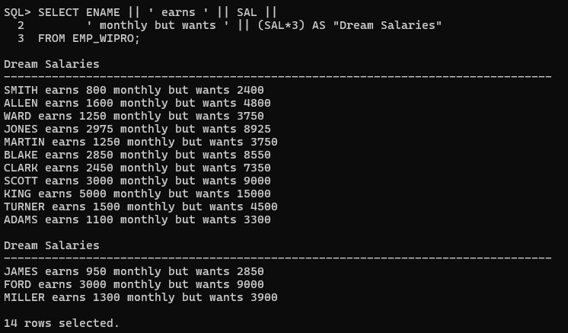
Assignment 8
Question:
Create a query to display the last name and salary for all employees. Format the salary to be 15 characters long, left-padded with the $ symbol. Label the column SALARY.
Query:
SELECT ENAME,
LPAD(SAL,15,'$') AS SALARY
FROM EMP_WIPRO;
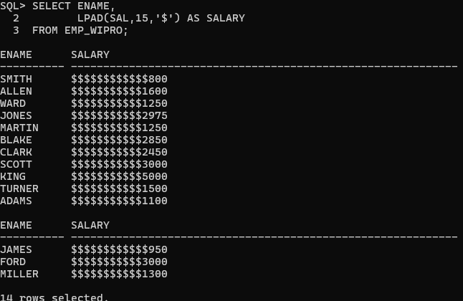
Assignment 9
Question:
Display each employee's last name, hire date, and salary review date, which is the first Monday after six months of service. Label the column REVIEW. Format the dates to appear in the format similar to Monday, the Thirty-First of July, 2000.
Query:
SELECT ENAME,
HIREDATE,
TO_CHAR(NEXT_DAY(ADD_MONTHS(HIREDATE,6),'MONDAY'),
'Day, DD Month YYYY') AS REVIEW
FROM EMP_WIPRO;

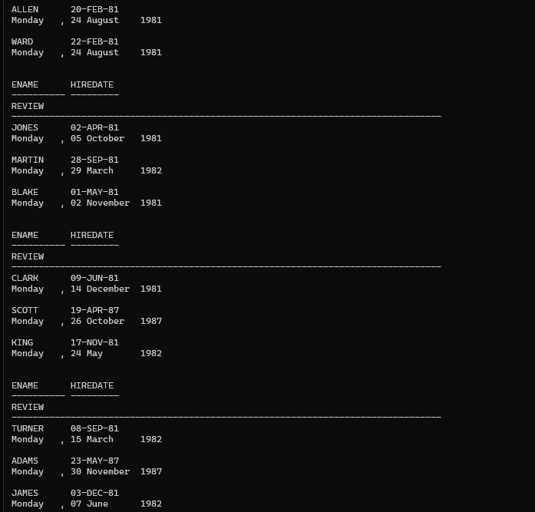
Assignment 10
Question:
Display the last name, hire date, and day of the week on which the employee started. Label the column DAY. Order the results by the day of the week, starting with Monday.
Query:
SELECT ENAME,
HIREDATE,
TO_CHAR(HIREDATE,'DAY') AS DAY
FROM EMP_WIPRO
ORDER BY TO_CHAR(HIREDATE,'D');
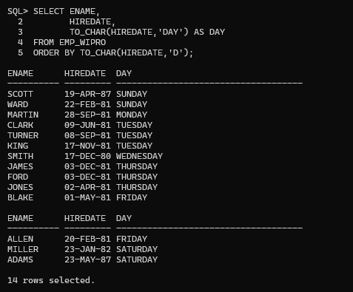
Assignment 11
Question:
Create a query that displays the employees' last names and commission amounts. If an employee does not earn commission, show No Commission. Label the column COMM.
Query:
SELECT ENAME,
NVL(TO_CHAR(COMM),'No Commission') AS COMM
FROM EMP_WIPRO;
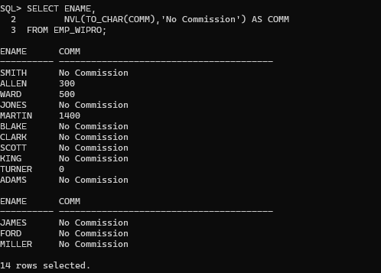
Assignment 12
Question:
Create a query that displays the first eight characters of the employees' last names and indicates the amounts of their salaries with asterisks. Each asterisk signifies a thousand dollars. Sort the data in descending order of salary. Label the column EMPLOYEES_AND_THEIR_SALARIES.
Query:
SELECT RPAD(SUBSTR(ENAME,1,8),8) || ' ' ||
RPAD('*',ROUND(SAL/1000),'*')
AS EMPLOYEES_AND_THEIR_SALARIES
FROM EMP_WIPRO
ORDER BY SAL DESC;
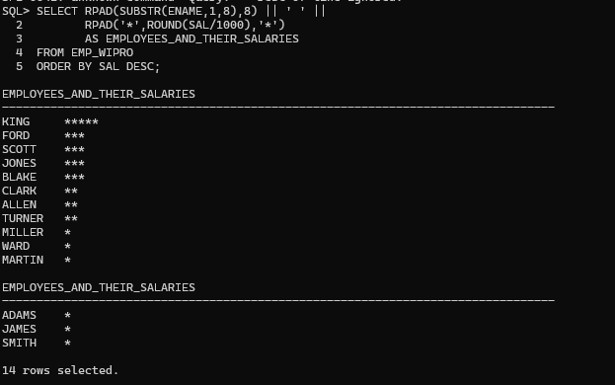
Assignment 13
Question:
Using the DECODE function, write a query that displays the grade of all employees based on the value of the JOB column using the following data:
- PRESIDENT → A
- MANAGER → B
- SALESMAN → C
- CLERK → D
- ANALYST → E
Query:
SELECT ENAME,
JOB,
DECODE(JOB,
'PRESIDENT','A',
'MANAGER','B',
'SALESMAN','C',
'CLERK','D',
'ANALYST','E',
'N/A') AS GRADE
FROM EMP_WIPRO;
